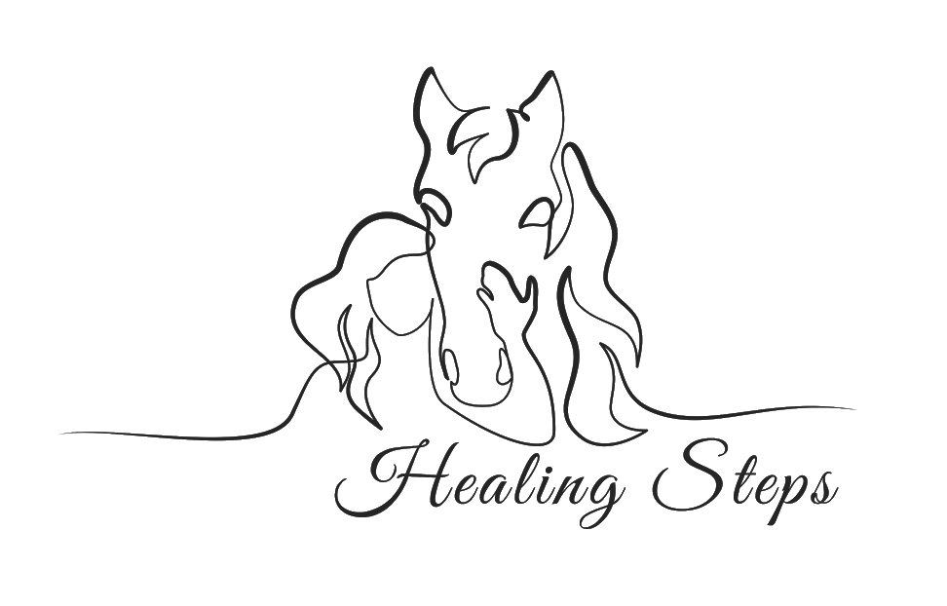

Precautions or Contraindications

The following conditions, if present, may represent PRECAUTIONS or CONTRAINDICATIONS for our Rehabilitation Services Team. Therefore, when completing the new client questionnaire, it is important to note whether these conditions are present, and to what degree.

Orthopedic:
- Spine
  - Fusion
  - Instabilities/Abnormalities, including Atlantoaxial Instability (common with Down Syndrome, JRA)
  - Scoliosis/Kyphosis/Lordosis
  - Spinal Orthoses
  - Internal Spinal Stabilization Devices (such as Harrington Rods)
- Hip
  - Hip Subluxation and Dislocation
  - Coxarthrosis
- General
  - Pathologic Fractures
  - Heterotopic Ossification
  - Osteogenesis Imperfecta
  - Osteoporosis
  - Cranial Deficits
  - Joint instabilities

Neurological:
- Hydrocephalus/shunt
- Spina Bifida
- Tethered Cord
- Chiari II Malformation
- Hydromyelia
- Paralysis due to Spinal Cord Injury (above T-6)
- Seizure disorder or history of seizures

Medical/Surgical:
- Allergies to Grasses, Animals, and Dust
- Cancer
- Poor Endurance
- Recent Surgery
- Diabetes
- Peripheral Vascular Disease
- Varicose Veins
- Hemophilia
- Hypertension
- Serious Heart Condition
- Stroke (Cerebrovascular Accident)
- Acute exacerbation of chronic disorder (Rheumatoid Arthritis, Herniated Disk, Multiple Sclerosis, etc)
- Open wound over weight bearing surface
- Indwelling urethral catheter

Other:
- Mental/behavioral disorders that would be unsafe (fire setting, animal abuse, violent behavior, etc)
- Weight over 190 lbs.

